Mini Project

1.

Name – K. M. Charan Romi

Student number – S92075569

Batch – 2

2.

Problems – Creating a tourist website, creating pages for the website

Sub problems – creating 5 web pages, deciding what web technologies to be used to coding

3.

Solution approach – Create a website with 5 distinctive web pages such as Home, about us, contact us, tourist information and Todo list.

Use Html, CSS and JavaScript to code website.

4.

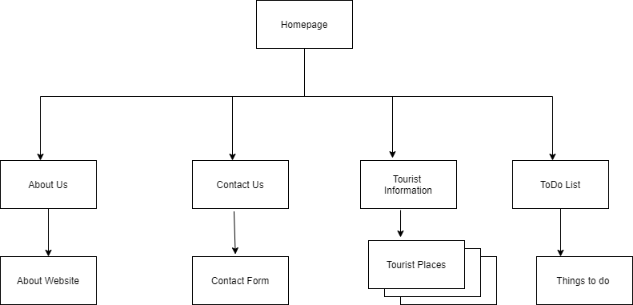

6.

Html

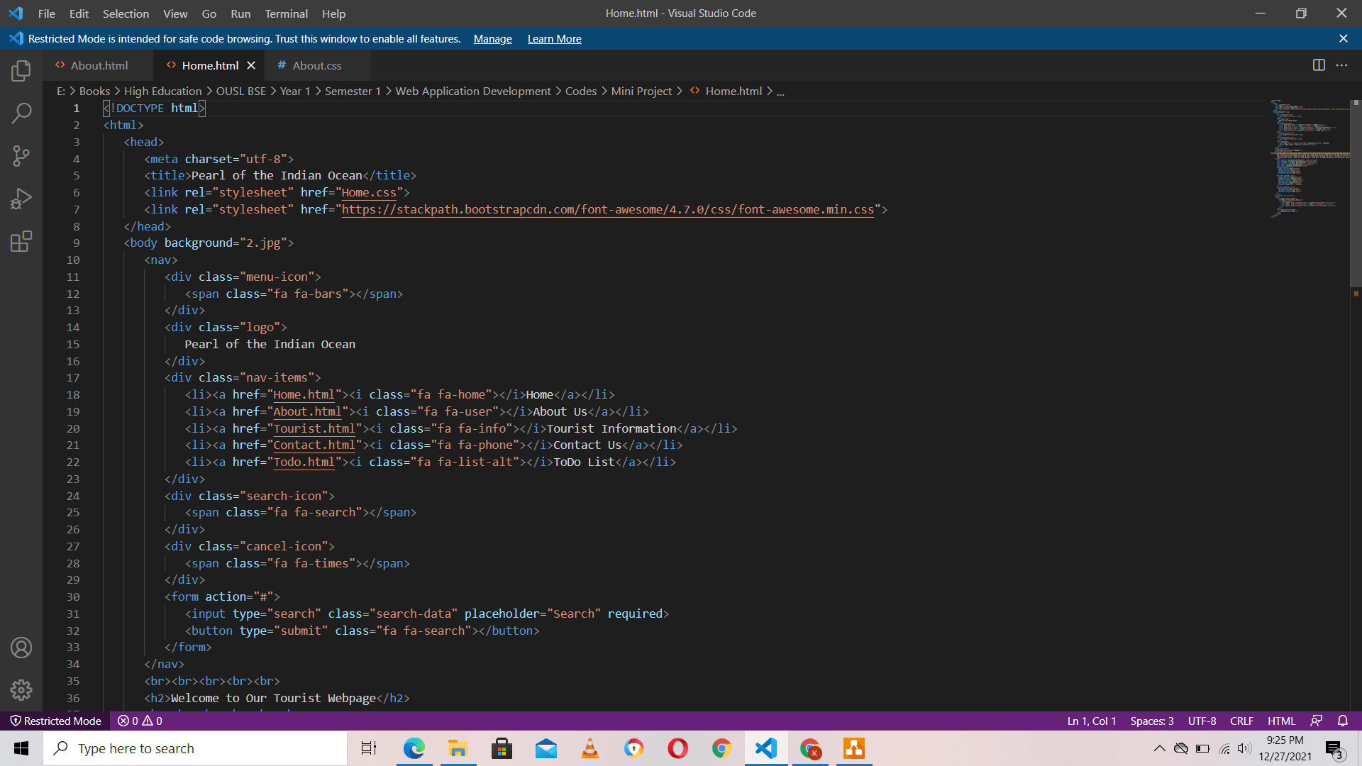

CSS

JavaScript

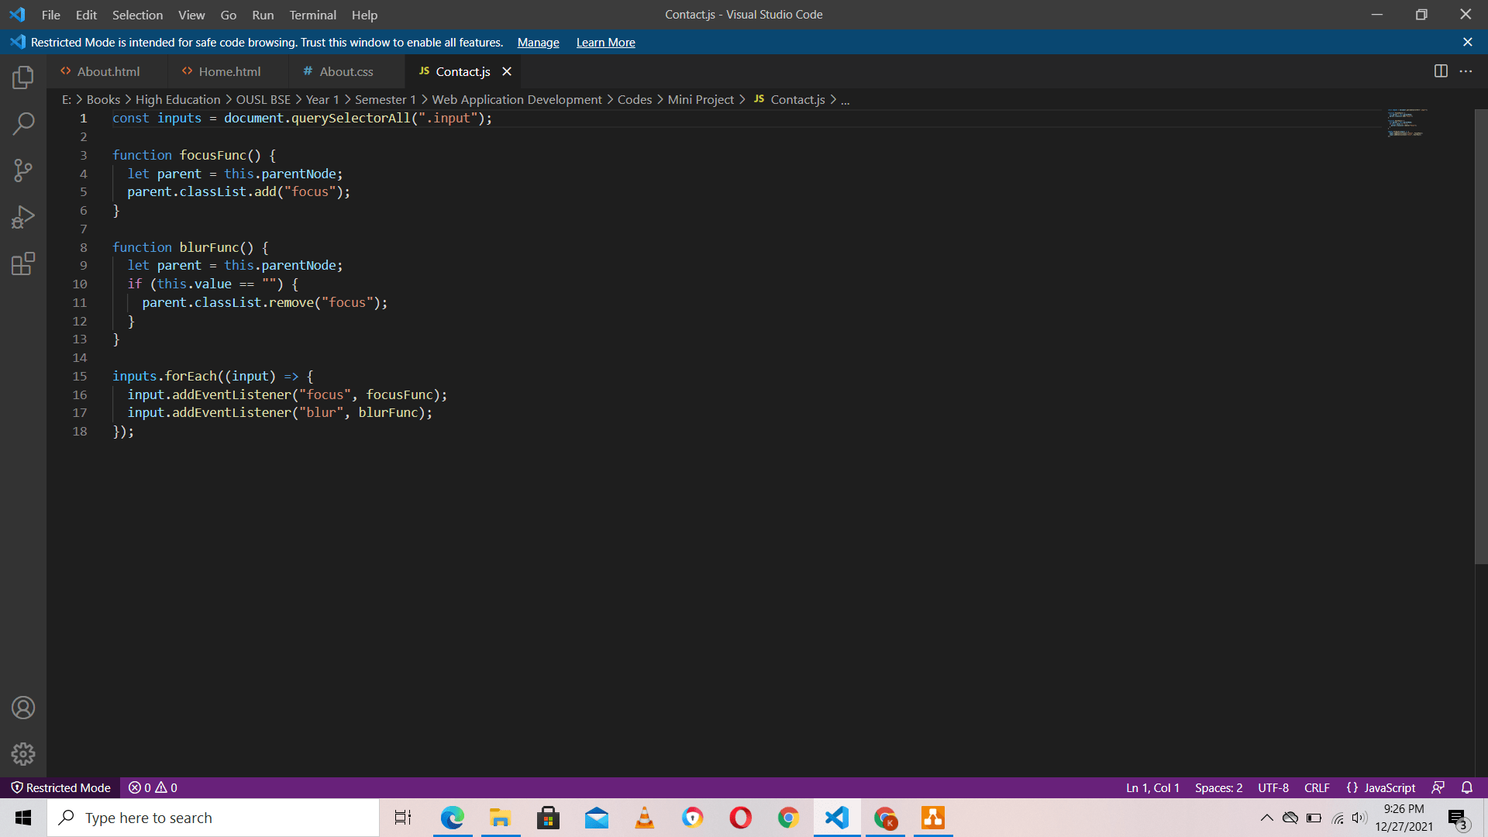

VueJs

7.

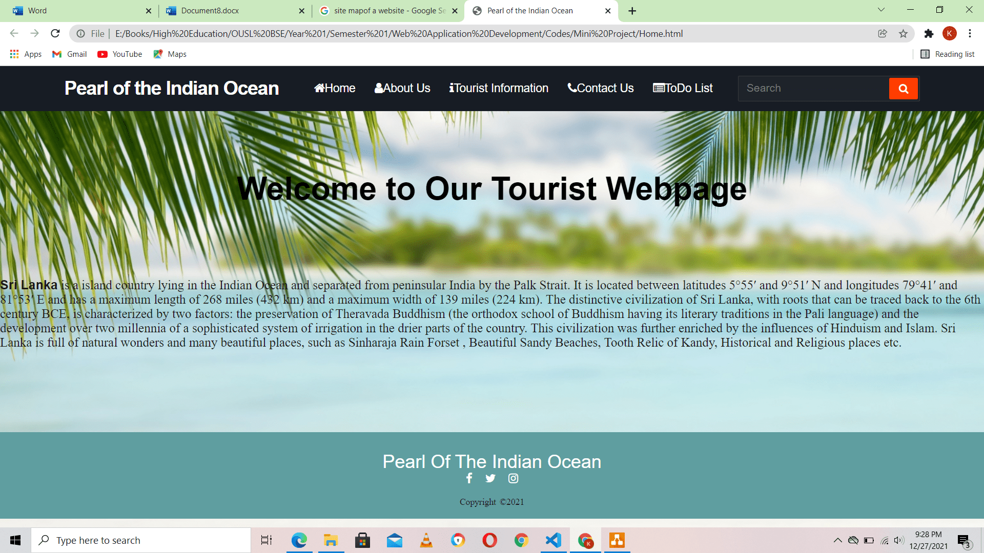

Homepage

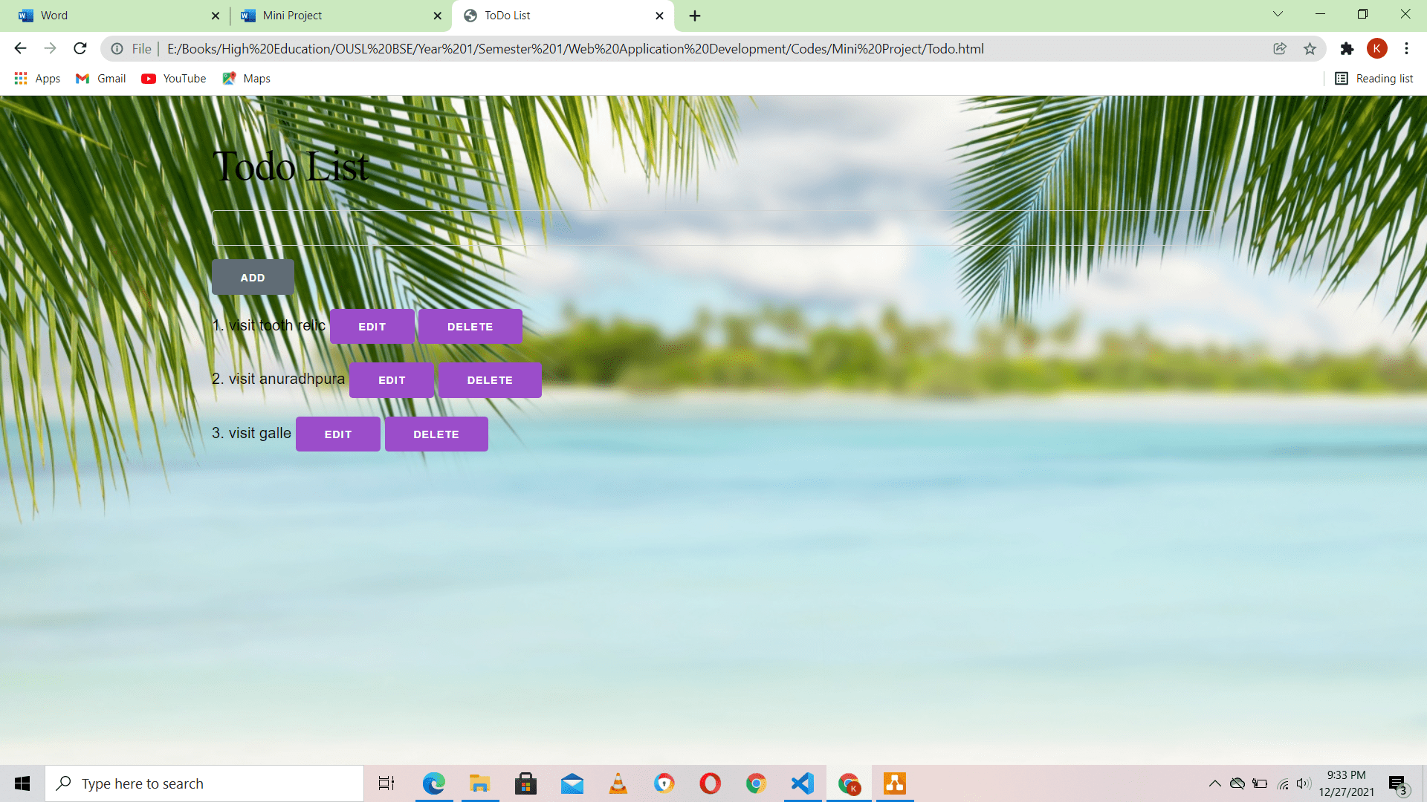

Todo list

8.

Conclusion – Tourist website was created according to web design standards and using suitable web technologies.